**Functional Design Document – Portal Front End for the WMS Host.**

1. Table of Contents

Distribution and Revisions 4

Introduction and Scope 5

Scope of the project 5

User Authentication 5

Master Data Management 5

Inbound Management 5

Outbound Stock management 6

Reporting functionality 6

Configuration 7

Web Services API 7

System Overview 7

High Level User Requirements 7

System Characteristics 8

System Architecture and Infrastructure Services 8

Solution Design 9

Solution Components Overview 9

Authentication and Login 9

Master Data Management 11

Incoming Goods Process 13

Data Tables, Views and Stored procedures 16

MatFlo Reporting database. 16

WMS Host database tables and Views 16

Auditing / User AuthenticationTables 17

Customer Master Data Management 18

Incoming goods management 18

Outbound Goods Management 19

Web Service API 20

Authentication 20

Products Related 21

Master Data 21

Incoming Goods Management 21

Outgoing / Orders 21

Screen Layouts 21

Authentication / Login 21

Master Data Management 22

Product management 22

Add new product 23

Master data customer management 25

Master data add new customer 25

Master Data Inventory 27

Incoming goods management 28

Inbound Summary 28

Create new inbound item 29

Inbound Receiving 29

Ordering / Outgoing goods management 30

Add new order – Outbound 30

Reports 32

1. Index of Tables

Table 1 - Revision History 4

Table 2 - Document Sign Off 4

Table 3- Audit.Action 17

Table 4 - Audit.ActionType 17

Table 5 - User Authentication details 17

Table 6 - Customer.Principal 18

Table 7 - Customer.Detail 18

Table 8 - Product.IGDRisk 19

Table 9 - Product.IGDStaging 19

Table 10 - Orders.Orders 20

Table 11 - Orders.LineItems 20

Table of Figures

Figure 1 High Level Authentication 10

Figure 2 Password Recovery 11

Figure 3 - Add Edit Customer 12

Figure 4 - Add Edit Product Details 13

Figure 5 – Incoming Goods Process 14

Figure 6 - Ordering Process 15

Figure 7 - XLSX Order Processing 16

Figure 8- Authentication 21

Figure 9 - Log In 22

Figure 10 - Product Management – Master Data Product 23

Figure 11 - Add new product 24

Figure 12 - Master customer management 25

Figure 13 - Master Add new customer 26

Figure 14 - Master Product Management 27

Figure 16 – Inbound Goods Summary 28

Figure 17 - Create New Inbound Item 29

Figure 18 - Inbound Receiving 30

Figure 19 - Add new order – Single receiver 31

Figure 20 - Add new order - Multiple receivers 32

Figure 21 - Reporting 33

# Distribution and Revisions

|  |  |  |  |
| --- | --- | --- | --- |
| Version | | Date | Revision Detail |
| 0.1 | 4 Dec 2014 | | Base document |
|  |  | |  |
|  |  | |  |
|  |  | |  |
|  |  | |  |
|  |  | |  |
|  |  | |  |

Table 1 - Revision History

|  |  |  |
| --- | --- | --- |
| Name | Date | Signature |
|  |  |  |
|  |  |  |
|  |  |  |
|  |  |  |
|  |  |  |
|  |  |  |
|  |  |  |

Table 2 - Document Sign Off

# Introduction and Scope

This document is the Functional Design Specification for the Warehouse Management System Customer Portal.

This document will detail all the required functionality as well as the interfaces that will be required to the WMS (MatFlo) as installed at RAM.

A need has been identified whereby RAM’s Warehousing clients need to log onto the RAM portal and manage their warehoused stock. This includes the management of incoming goods (to RAM’s warehouse), as well as the management of placing orders and having these shipped to their individual clients.

An important thing to note: This system is NOT a financial management system, but a tool to provide warehouse management for goods.

## Scope of the project

The scope of the project is to be limited to providing the following sections:

### User Authentication

User authentication will encompass the following functions:

* Logon of individual customers. These customers will be linked to a Principal and will only have access to their own stock items.
* Logon of warehouse staff to facilitate the processing of inbound goods.
* Management of permissions assigned to logged on users
* Password management – users may change their own passwords. Forgotten passwords are managed through the system and will have email token confirmation.
* Permission management. This will allow the “super users” within the system, and associated with certain clients, to assign privileges to user accounts registered within the WMS Host.

### Master Data Management

This section describes the management of the following:

* The management of address and other shipping data for the clients. These addresses will be entered and validated against the new geolocation model that RAM is implementing.
* Management of stock descriptions and codes within MatFlo.

### Inbound Management

* The interaction between the WMS Host and the WMS system for the entry and notification of stock.
* Uploads using XLSX files for product definitions and IGD messages. This may only be handled in later phases of the development lifecycle.
* Management of Incoming stock descriptions. Checks will be incorporated to effectively manage the creation and deletions of stock item descriptions etc.
* The ability to retrieve stock counts and product related data from the WMS.
* A Web based User Interface for the creation and management of inbound goods to the warehouse from the Client’s suppliers.
* Cost prices of inbound goods needs to be entered with every consignment delivered to the RAM warehouses. This is used to calculate RAM’s risk on the items warehoused on the Client’s behalf. Risk calculation will be performed by using the cost price of the goods and then averaging this against the amount that will be in stock. The average values should be stored within the database.

### Outbound Stock management

This section will detail the complete order process that can be accessed by an authorized user.

* Client Orders. Manual form based input.
* Shipping of the ordered goods.
* Real –time retrieval of current stock counts within the warehouse to advise on the availability before an order is placed.
* Order placing using the import and validation of XLSX files. May only be implemented in a later phase of the project.

### Reporting functionality

Predefined reports are to be designed which will give the users the ability to retrieve data online as per their permissions.

* Reports which should be generated includes:
  + Overall stock levels per customer
  + Awaiting goods descriptions
  + Orders placed and their statuses
* Management reports for RAM’s use should include
  + A complete stock list from the WMS – per principal
  + The risk (albeit a best effort calculation) associated with the stock stored in the warehouse.

The reporting modules should also be able to provide real time information per client such as:

* Product definitions – which will be used to populate lists online while the users place orders.

### Configuration

Configuration will be handled based on the current RAM Management system whereby users / entities are granted specific rights as to certain functionality.

This functionality may be broken down into:

* User management per client
* Access to Reporting
* Access to master data maintenance
* Access to inbound management
* Access to outbound management
* Access to product management

Super Users will have access to the Configuration pages to enable / disable functionality for registered users.

### Web Services API

SOAP Web Services will be exposed to enable the direct integration from clients to RAM’s Warehouse Host. These services will be hosted directly on the WMS Host.

The envisaged services include:

* Authentication to the system
* Inbound goods management
* Outbound goods management (placing of orders)
* Management of client details (as in the master data management).

# System Overview

## High Level User Requirements

1. A user (linked to a Principal) needs to log onto a web portal to enable them to access warehouse management functionality.
2. All activity on this site must be logged for auditing and traceability.
3. A super user from a principal must be able to assign permissions to other users for the same principal.
4. Users must be able to manage their own passwords and recover them if required.
5. Users should only have access to the data for their assigned principal.
6. Warehouse staff should be able to access more than one principal to enable the manual management of IGD messages to the warehouse.
7. The user should also be able to manage, edit and add, the addresses of the receivers where-to goods will be delivered. All addresses should be validated to ensure that they conform to the geolocation principles that RAM is implementing.
8. A user (warehouse staff included) should have access to manage inbound goods that will be delivered to the warehouse. This includes the management of product codes as well as the quantities that are expected to be delivered to the warehouse.
9. A user must be able to access an ordering (outbound goods) facility. This must include various checks to ensure that stock is available before placement of orders. The web UI should provide up to date product counts and details to ensure a speedy ordering process.
10. Users will also need to access certain reports to enable their management and billing functions.
11. Provision must be made for the calculation of RAM’s risks based on the value of the incoming goods.

## System Characteristics

The description of the system is given in terms of the Architecture of the solution that is being implemented with high level data flows described to set the context of the system, i.e. to look at its external interfaces. This section also sets out to ‘characterize’ the system describing aspects of its operation that indicate if the system has, amongst others:

* The system must operate in real time
* The User Interface is to be provided as a web front end linked to the RAM Portal
* The number of concurrent users should be scalable and should be able to accommodate a large number of users
* Highly resilient and fault tolerant
* All possible security features must be incorporated to protect company and operational data
* Easily maintainable

No records in the database will be deleted, only marked as inactive.

## System Architecture and Infrastructure Services

The solution will be built using current frameworks that have been incorporated in other RAM systems.

The main focus areas of integration are:

* Security – The control of access to the WMS Portal
* Auditing – To ensure complete traceability of any transaction by a user
* Reporting – Provision of accurate information for billing etc.
* Error Handling – The system has to be resilient
* Logging – Provided mainly for debugging purposes.
* User Interfaces – The mechanism against which users interact with the system
* System Web Interfaces – For future client system integration possibilities
* Data Interfaces

### Solution Design

The system under consideration will perhaps be based upon an n-tier, client-server architecture.

The envisaged tiers are:

* Client access / presentation tier. This is where the user interacts into the system using a Web UI.
* Data access / persistence tier.
* Business tier. Containing business logic such as the management of master data as well as the ‘business rules’ for simple processes.
* WMS Host -> MatFlo tier

The solution will be built using the ASP.NET Web Forms design pattern as it provides for rapid application development and does not break the model of current RAM web based applications.

## Solution Components Overview

### Authentication and Login

By definition, portals imply content and functionality tailored to individual users. The first step is to identify the users accessing the portal. The suggested model for authentication will be based on the ASP.Net Identity 2.0 framework. This framework allows for the most flexibility and should be able to accommodate the authentication model that will provide functionality for the management of user passwords by the users themselves. Email based confirmation will be employed to confirm the authenticity of users when changing passwords. This solution may in future be expanded to include SMS validation as part of a 2 stage validation in addition to the email validation.

No passwords will be stored within any RAM system. Only hashes will be stored against which passwords will be validated.

Cookies may be used to store the expiration time for the session as well as other details required for authentication and validation. The security cookie token should be self-signed using the ProtectedData API within the System.Security.Cryptography class.

#### User registration process

Super Users will be registered through the normal customer vetting process on the addition of a new client. This entry will be entered into the current RAM Management system as a new user.

The email address will in this case also constitute the User Login ID.

Email address to be communicated to customer and will be asked to reset password since a default will be seeded to the database.

All transactions within the System will be logged to an Auditing database to ensure complete traceability of any transaction.

#### Authentication Process Flow

The following process describes the authentication process in a high level.



Figure 1 High Level Authentication

#### Password Recovery Process

WMS Portal Users will need the functionality to reset / change their passwords for access. This flow diagram details this.



Figure 2 Password Recovery

### Master Data Management

Product description details as well as core client details are captured and managed using these processes as defined below.

#### Add / Edit Address entries – Geolocation validation

When addresses are added and / or edited within the system, various validation steps needs to be applied to insure data integrity.

This will include searches for duplicates as well as correctness of geolocation information.



Figure 3 - Add Edit Customer

#### Master Data – Add New / Edit Product

Editing of product data should only be performed when a zero stock level count for a specific product is encountered. Care should be taken that duplicate products not be registered. This will complicate the ordering process whereby two or more product descriptions may exist for the same product.

Filtering and checks should be can be made at a high level against:

* The SKU
* The product short description
* The EAN Code



Figure 4 - Add Edit Product Details

## Incoming Goods Process

New goods as inbound to the warehouse needs to be predefined by the clients before stock is expected at the warehouse.

In the unfortunate case where stock is not “pre-notified” by the client, the warehouse staff will need to log on and manually create the IGD messages for each arriving stock item.

During the incoming goods process, calculation of RAM’s risk has to be performed.



Figure 5 – Incoming Goods Process

#### Order Process (Outbound goods process)

Manual Ordering from the user Interface will follow the process as detailed below.

The client should be able to create multiple orders using the user interface. Each of these orders will be validated separately, but a batch request is then sent to the MatFlo system.



Figure 6 - Ordering Process

Additionally, orders may at a later stage be imported using XLSX Files generated by the clients themselves and uploaded into the WMS Portal for batch processing.

Various checking and validations need to be performed on the XLSX File before being accepted for upload. These may include the following checks:

* Send To addresses validated against geolocation model
* Stock availability for each line item



Figure 7 - XLSX Order Processing

# Data Tables, Views and Stored procedures

## MatFlo Reporting database.

The following database tables and views are already configured on the MatFlo reporting server, and will be used for the retrieval of product data and their corresponding stock levels.

Definition of these tables can be found in the document: [**APEX-1212 -Ram - MatFlo - FDS 1 1.docx**](../../RAM_WMS_Host/RAM_WMS_Host/Docs/APEX-1212%20-Ram%20-%20MatFlo%20-%20FDS%201%201.docx)

## WMS Host database tables and Views

The following tables and views are required to support the management of the Incoming data, Outgoing goods as well as the Auditing of transactions.

All additional Tables not specified within this document can be found in the documents as referenced:

Please see [**RAM_WMS_Host_Matflo_Integration.docx**](../../RAM_WMS_Host/RAM_WMS_Host/Docs/RAM_WMS_Host_Matflo_Integration.docx) **as well as** [**Matflo Message Tables.xlsx**](../../RAM_WMS_Host/RAM_WMS_Host/Docs/Matflo%20Message%20Tables.xlsx) for additional information.

### Auditing / User AuthenticationTables

|  |  |  |  |  |
| --- | --- | --- | --- | --- |
| Field Name | Type | Allow Null | | Description |
| _ID | uniqueidentifier | N |  | |
| ActionDateTime | datetime | N |  | |
| ActionUser | Varchar (50) | N |  | |
| ActionStation | Varchar (50) | N |  | |
| ActionDetails | XML | N |  | |
| ActionType | uniqueidentifier | N |  | |

Table 3- Audit.Action

|  |  |  |  |
| --- | --- | --- | --- |
| Field Name | Type | Allow Null | Description |
| _ID | uniqueidentifier |  |  |
| ActionType | Varchar (50) |  |  |
| ActionDescription | Varchar (50) |  |  |

Table 4 - Audit.ActionType

|  |  |  |
| --- | --- | --- |
| Field Name | Type | Description |
| Email Address | Varchar (256) | Main User Name |
| IsActive | byte | Is this account active |
| CustomerID | Varchar(256) | The main principal to which this account is linked. |
| FirstName | Varchar(256) | First Name |
| LastName | Varchar(256) | Last Name |
| TelephoneNumber | Varchar(256) | Telephone Number |
| CellphoneNumber |  |  |
| FaxNumber |  |  |
|  |  |  |

Table 5 - User Authentication details

### Customer Master Data Management

|  |  |  |  |
| --- | --- | --- | --- |
| Field Name | Type | Allow Null | Description |
| _ID | uniqueidentifier |  | Record ID (PK) |
| PrincipalName | Varchar (50) |  | The name of the Principal |
| AdditionalNotes | Varchar (50) |  | Additional Notes |
| Address1 | Varchar (50) |  |  |
| Address2 | Varchar (50) |  |  |
| Suburb | Varchar (50) |  |  |
| PostalCode | Varchar (50) |  |  |
| Telephone | Varchar (50) |  |  |
| RegistrationNumber | Varchar (50) |  |  |
| ImportExportCode | Varchar (50) |  |  |
| DeletedFlag | bit |  | Deleted? |

Table 6 - Customer.Principal

|  |  |  |  |
| --- | --- | --- | --- |
| Field Name | Type | Allow Null | Description |
| _ID | uniqueidentifier |  | Record ID (PK) |
| PrincipalID | uniqueidentifier |  | FK - Customer.Principal PrincipalID |
| AccountNumber | Varchar (50) |  | BilledTo |
| InvoiceToName | Varchar (50) |  | Invoice Name |
| InvoiceAddress1 | Varchar (50) |  | Address Line |
| InvoiceAddress1 | Varchar (50) |  | Address Line |
| InvoiceAddress1 | Varchar (50) |  | Address Line |
| InvoiceAddress1 | Varchar (50) |  | Address Line |
| InvoiceAddress1 | Varchar (50) |  | Address Line |
| InvoiceAddress1 | Varchar (50) |  | Address Line |
| DeliveryAddress1 | Varchar (50) |  | Address Line |
| DeliveryAddress1 | Varchar (50) |  | Address Line |
| DeliveryAddress1 | Varchar (50) |  | Address Line |
| DeliveryAddress1 | Varchar (50) |  | Address Line |
| DeliveryAddress1 | Varchar (50) |  | Address Line |
| DeliveryAddress1 | Varchar (50) |  | Address Line |
| TelephoneNumber | Varchar (50) |  | Tel Number |
| VATNumber | Varchar (50) |  | VAT Number |
| Active | bit |  | Is this custyomer still active – can place orders? |
| DeliveryCoordinates | Varchar (50) |  | Geolocation coords |
| DeletedFlag | bit |  | Deleted? |

Table 7 - Customer.Detail

### Incoming goods management

|  |  |  |  |
| --- | --- | --- | --- |
| Field Name | Type | Allow Null | Description |
| _ID | uniqueidentifier |  | Record ID (PK) |
| PrincipalID | uniqueidentifier |  | FK - Customer.Principal PrincipalID |
| DeletedFlag | bit |  | Deleted? |
| IGDID | bigint |  | FK – RAMWMSHOST.MSGOUT_IDG.ID |
| CostPrice | currency |  | The cost price of the item |
| CalculatedAverage | currency |  | Calculated average based on previous IGD’s |

Table 8 - Product.IGDRisk

|  |  |  |  |
| --- | --- | --- | --- |
| Field Name | Type | Allow Null | Description |
| _ID | int |  | Record ID (PK) |
| PrincipalID | uniqueidentifier |  | FK - Customer.Principal PrincipalID |
| RecordDT | Varchar (50) |  | Order Number |
| RecordState | datetime |  |  |
| ProdCode | Varchar(20 |  |  |
| EANCode | Varchar(20) |  |  |
| ShortDesc | Varchar(20) |  |  |
| LongDesc | Varchar(40) |  |  |
| Serialised | bit |  |  |
| AnalysisA | Varchar(10) |  |  |
| AnalysisB | Varchar(10) |  |  |
| OrderLineNo | Varchar(4) |  |  |
| Quantity | int |  |  |
| ReceiptType | Char(1) |  |  |
| MoveRef | varchar(10) |  |  |
| PORef | varchar(10) |  |  |
| PODate | datetime |  |  |
| DeletedFlag | bit |  | Deleted? |

Table 9 - Product.IGDStaging

### Outbound Goods Management

|  |  |  |  |
| --- | --- | --- | --- |
| Field Name | Type | Allow Null | Description |
| _ID | uniqueidentifier |  | Record ID (PK) |
| PrincipalID | uniqueidentifier |  | FK - Customer.Principal PrincipalID |
| OrderNumber | Varchar (50) |  | Order Number |
| DateCreated | datetime |  |  |
| CustomerDetailID | uniqueidentifier |  | FK - Customer.Detail._ID |
| CustomerOrderNumber | Varchar (50) |  |  |
| Priority | Varchar (50) |  |  |
| ValueAddedPackaging | Varchar (50) |  |  |
| SalesPerson | Varchar (50) |  |  |
| SalesCategory | Varchar (50) |  |  |
| Processor | Varchar (50) |  |  |
| OrderDiscount | Varchar (50) |  |  |
| OrderVAT | Varchar (50) |  |  |
| Source | Varchar (50) |  |  |
| ActionDateTime | datetime |  |  |
| DeletedFlag | bit |  | Deleted? |

Table 10 - Orders.Orders

|  |  |  |  |
| --- | --- | --- | --- |
| Field Name | Type | Allow Null | Description |
| _ID | uniqueidentifier |  | Record ID (PK) |
| OrderID | uniqueidentifier |  | Orders.Orders_ID |
| LineNumber | int |  |  |
| LineType | Varchar (50) |  |  |
| ProductCode | Varchar (50) |  |  |
| LineText | Varchar (50) |  |  |
| Quantity | Varchar (50) |  |  |
| UnitCost | Varchar (50) |  |  |
| VAT | Varchar (50) |  |  |
| UnitDiscountAmount | Varchar (50) |  |  |
| Completed | bit |  |  |
| CompletedDateTime | datetime |  |  |
| Source | Varchar (50) |  |  |
| ActionDateTime | datetime |  |  |
| Status | Varchar (50) |  |  |

Table 11 - Orders.LineItems

# Web Service API

SOAP Web Services are to be created for future integration possibilities from Customer’s Line of Business Solutions. These Web Services should cater for the following functionality:

Note: Final specifications to be defined as a next phase in the project.

### Authentication

Provides a mechanism to return a session token for transactions. This token should validate the transactions to belong to a specific principal and will henceforth be used for logging and auditing purposes.

### Products Related

* Product Definitions – Same validation to be placed on the creation of new products as will be used in the user interface.
* Retrieval of Product Counts by Product Name

### Master Data

* Update / Create customers

### Incoming Goods Management

##### Create incoming goods definitions

##### Maintenance of product details

### Outgoing / Orders

* Create orders

# Screen Layouts

Screen layouts are bound to change, but the general format is depicted here as guidance.

## Authentication / Login

Figure 8- Authentication

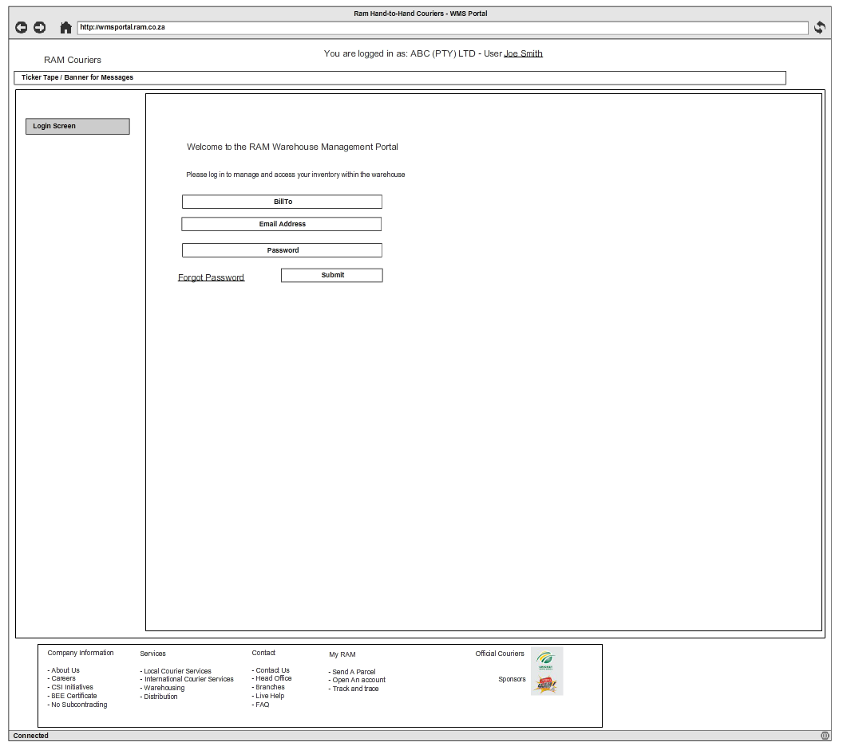

Figure 9 - Log In

Notes:

* Authentication will be linked to an email address.

## Master Data Management

### Product management

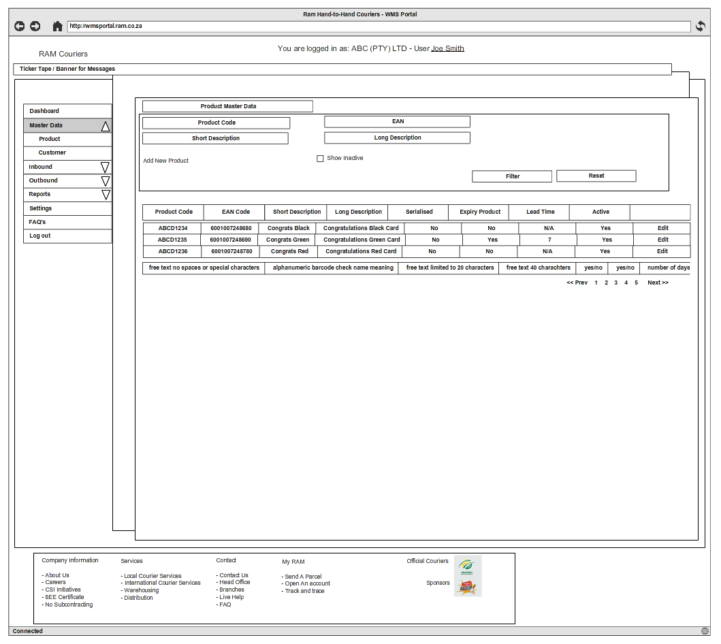

Figure 10 - Product Management – Master Data Product

Notes:

* Filters should be built in to provide more fine grained searching capabilities
* Active / Inactive product status can only be set if there is no stock in MatFlo
* TODO: Confirm if products can be made “Inactive” in MatFlo

### Add new product

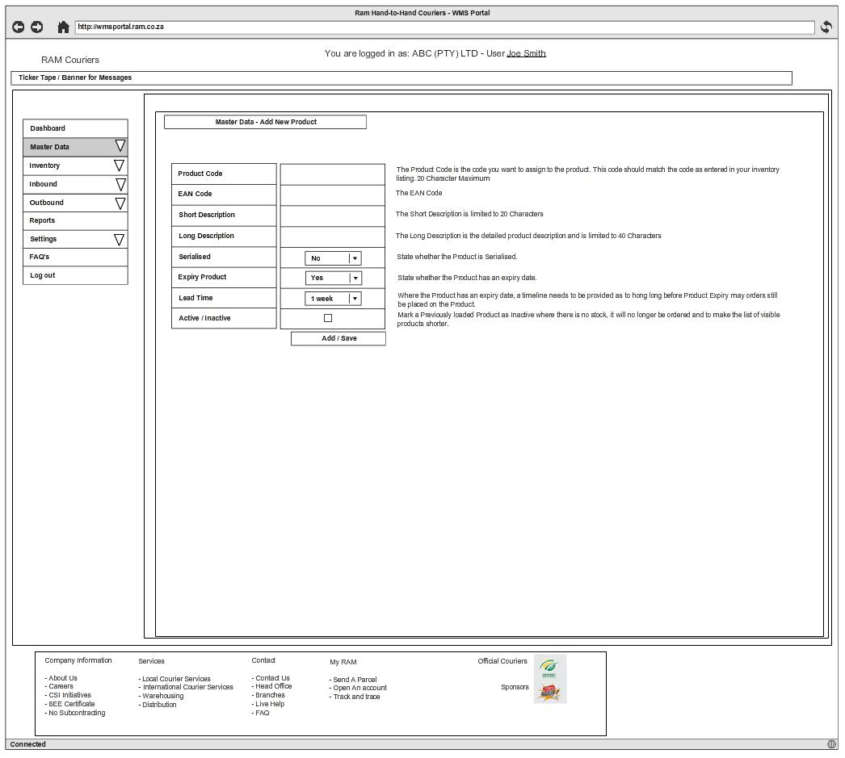

Figure 11 - Add new product

Notes:

* The product code used is the Client’s own product code
* TODO: Can a product description be changed using an IGD?
* The pending IGD’s have to be consulted in addition to the stock counts within Matflo before product related definitions can be updated

### Master data customer management

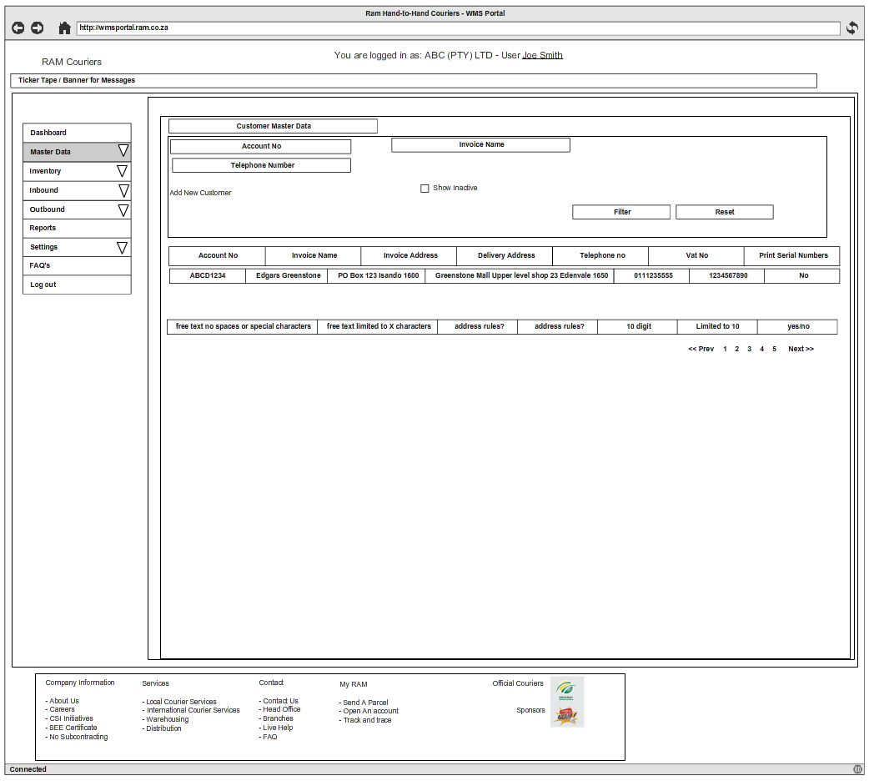

Figure 12 - Master customer management

Notes:

* This is the Client’s own “Receiver” list
* In addition to the Account Number, RAM also has to provide an internal RAM account number.

### Master data add new customer

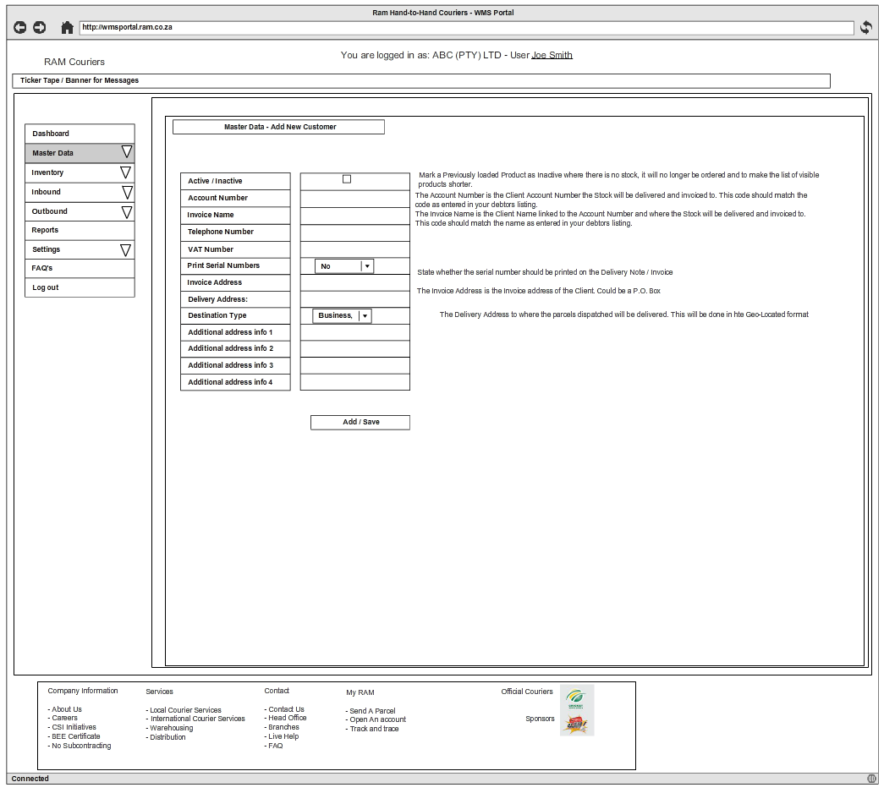

Figure 13 - Master Add new customer

Notes:

* Invoice Address could be a Postal Address.
* Delivery addresses should only be entered using the same type of mechanism that is used for address entry as the new RAM web site
* Address formats should be discussed with Johannes / Craig
* RAM’s account number is compiled as follows:
  + First 4 characters of the name + 3 characters HUB abbreviation + 5 numeric sequence OR
  + First 4 characters of the name + 6 characters BilledTo code + 5 digit numeric sequence.

### Master Data Inventory

##### 

Figure 14 - Master Product Management

Notes:

* Filters should be provided to narrow down results

## Incoming goods management

### Inbound Summary

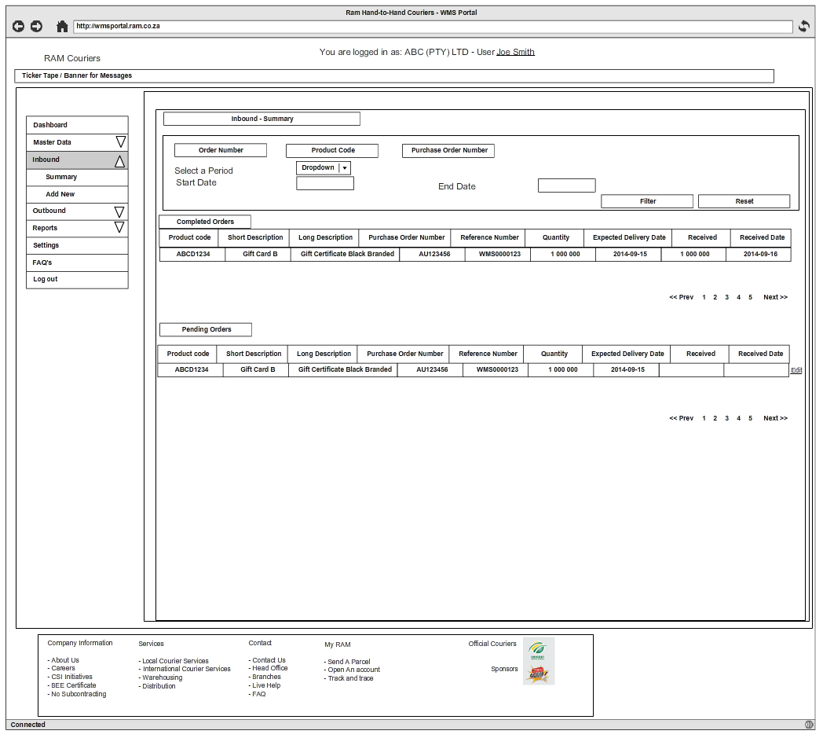

Figure 16 – Inbound Goods Summary

Notes:

* If the goods arriving from a Client, to RAM’s Warehouse, on an order number does not balance, goods should NOT be accepted into the warehouse. The Client will need to edit the IGD before acceptance – as per Graeme.
* This is a summary of the goods that are expected from the Client’s suppliers.

### Create new inbound item

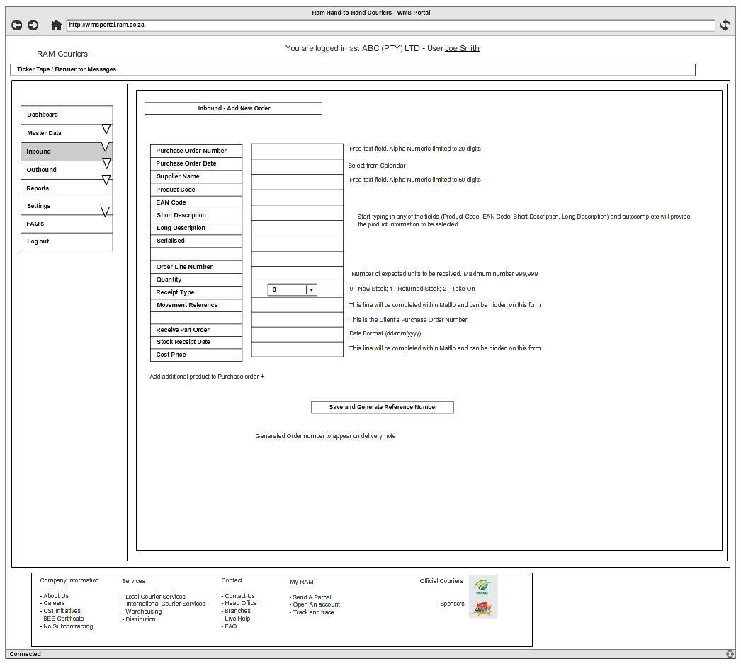

Figure 17 - Create New Inbound Item

Notes:

* The Client has to provide the price of the goods in this Incoming goods definition. This is used to calculate RAM’s risk of items stored in the warehouse. An average will be kept for each product and will be updated on any new IGD’s.

### Inbound Receiving

This functionality will only be accessed by the Warehouse staff.

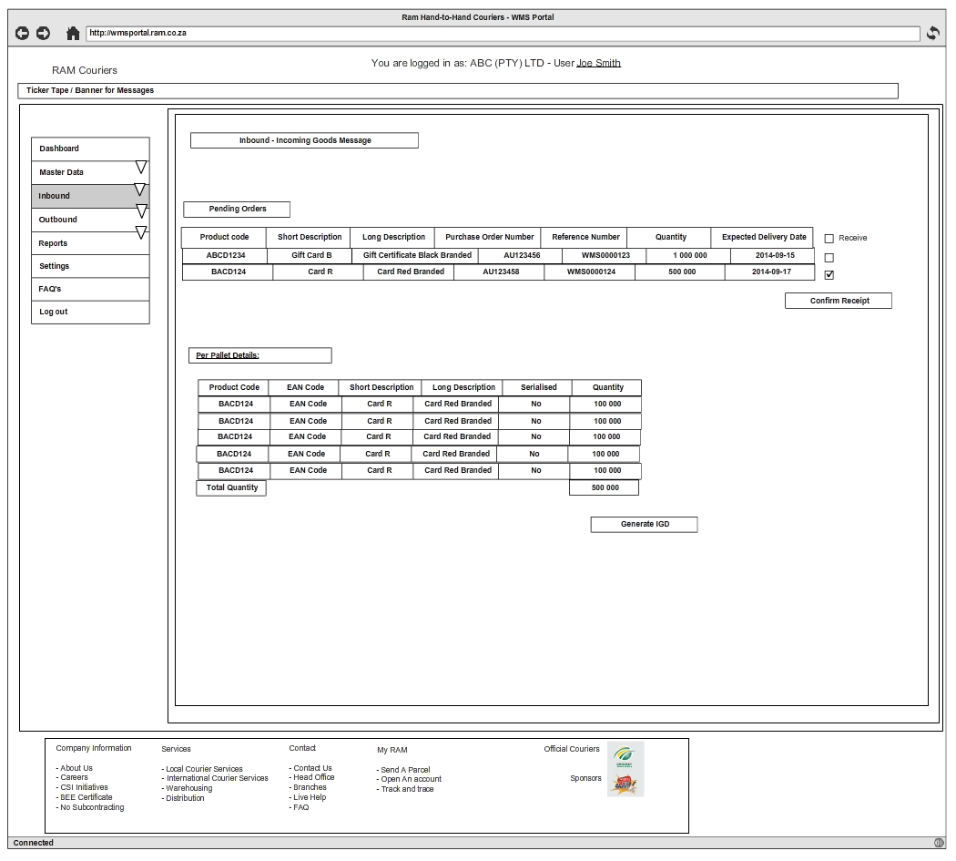

Figure 18 - Inbound Receiving

## Ordering / Outgoing goods management

### Add new order – Outbound

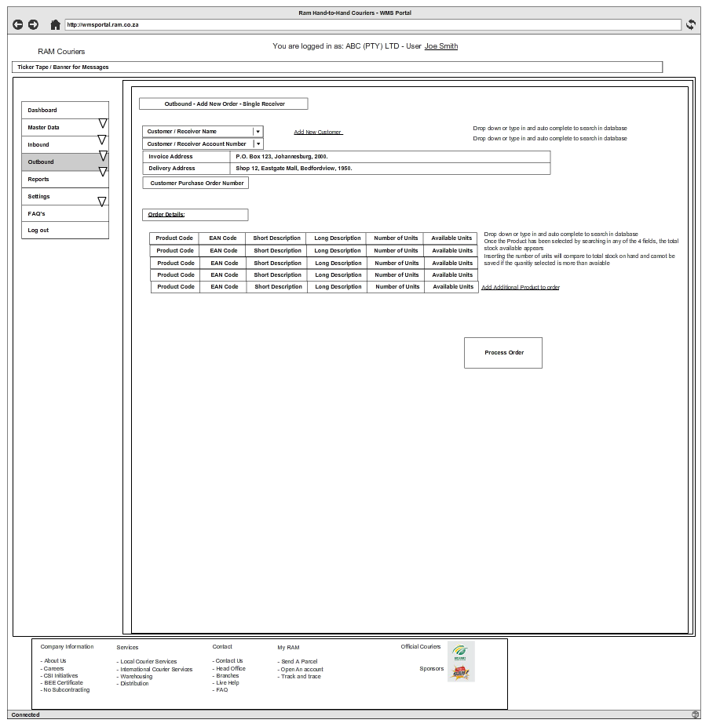

Figure 19 - Add new order – Single receiver

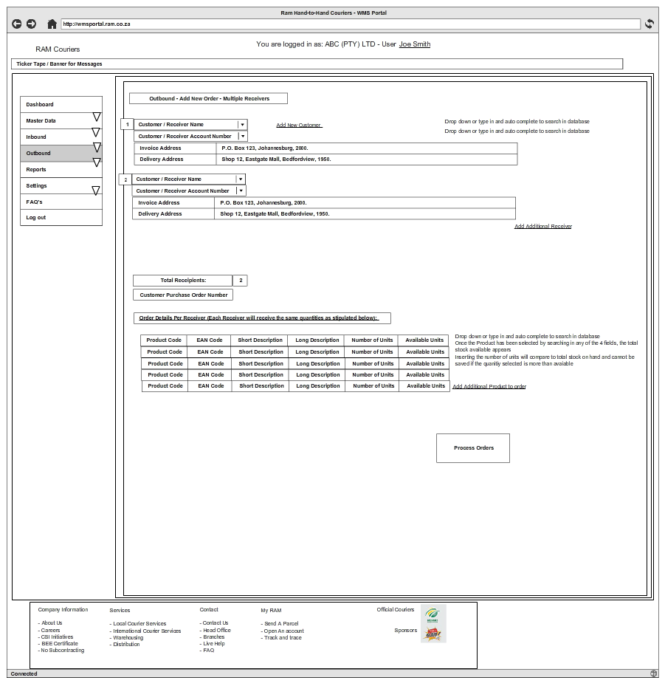

Figure 20 - Add new order - Multiple receivers

### Reports

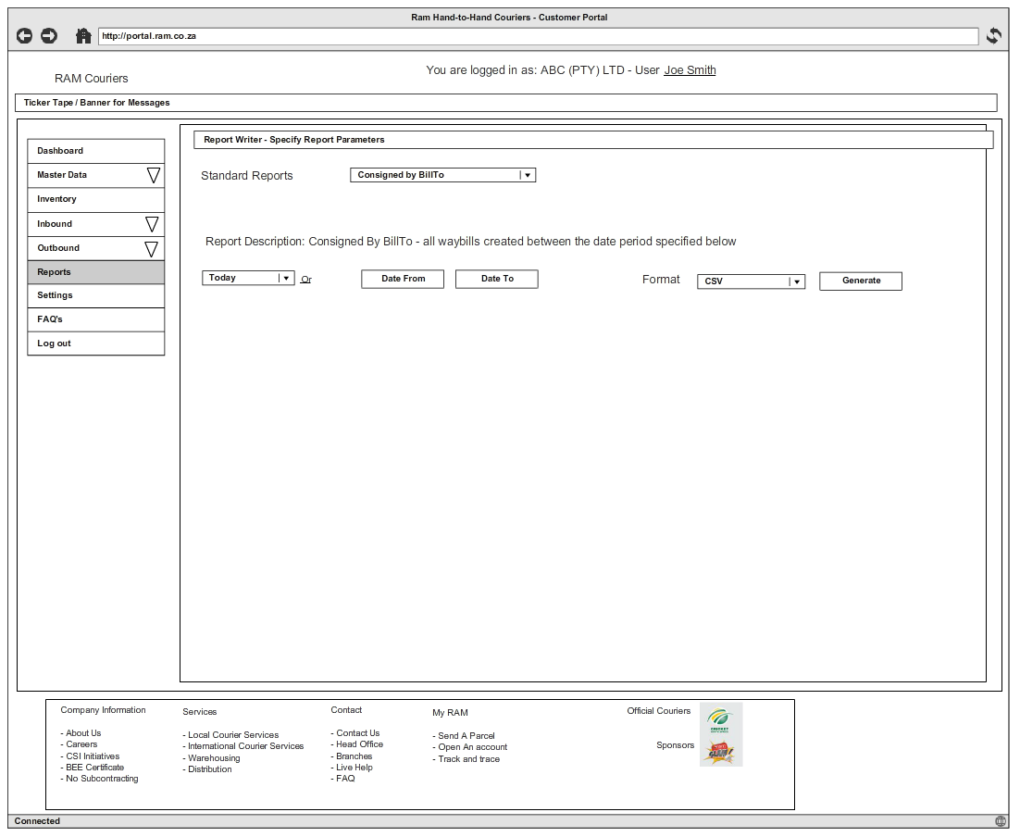

Figure 21 - Reporting